**📊 Case Study: Smart Store Sales Dashboard**

**📝 Project Overview**

The **Smart Store Sales Dashboard** is a Power BI project designed to provide **actionable business insights** for retail decision-making. The dashboard consolidates raw sales data into an interactive, easy-to-understand interface that enables businesses to track performance, analyze customer behavior, and forecast future sales trends.

**🎯 Business Problem**

Retail managers often struggle with:

* Identifying **top-performing products & categories**
* Understanding **regional performance variations**
* Analyzing **payment and shipping preferences**
* Forecasting sales to plan **inventory & marketing strategies**

Without a unified dashboard, these insights are scattered across reports, making decision-making **slow and inefficient**.

**💡 Solution Approach**

Using **Power BI**, I designed an **interactive dashboard** that:

1. Integrates sales, profit, and customer data.
2. Provides **visual storytelling** through clean charts & KPIs.
3. Highlights **key metrics** like top-selling products, monthly performance, and state-level sales.
4. Uses **forecasting techniques** to predict 20-day sales trends.

**🚀 Key Insights from the Dashboard**

* **Top Products:** Phones, Chairs, and Binders are the leading sub-categories.
* **Sales Trend:** Sales peak during November–December, showing strong seasonal demand.
* **Customer Segments:** Consumers (48%) are the largest contributing segment, followed by Corporate and Home Office.
* **Payment Modes:** COD (43%) is the most used, while online and cards contribute significantly.
* **Regional Analysis:** California, New York, and Texas are the top revenue-generating states.
* **Forecasting:** Predicted sales trends help in **demand planning** and **resource allocation**.

**📈 Business Impact**

With this dashboard, retail managers can:  
✅ **Optimize inventory** based on seasonal sales trends  
✅ **Plan targeted marketing campaigns** for high-performing states  
✅ **Improve customer experience** by analyzing payment & shipping preferences  
✅ **Make proactive decisions** using forecasting models

**🛠️ Tools & Technologies**

* **Power BI Desktop** – Dashboard design & visualization
* **Excel Dataset** – Data source for sales records
* **Forecasting Model** – Built-in Power BI time-series forecasting

**📷 Dashboard Preview**

1. **SmartStore Sales Dashboard:-**

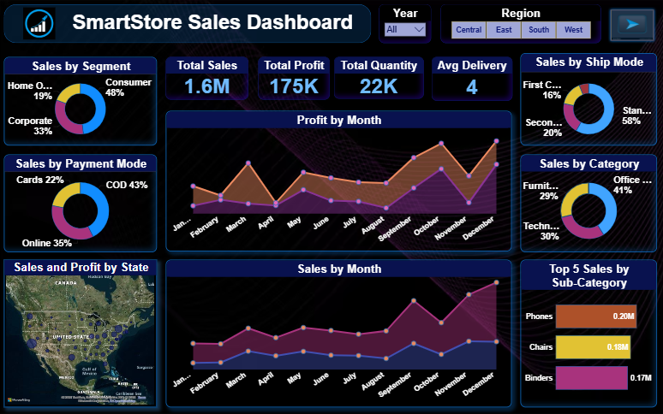

1. **Sales Forecast:-**

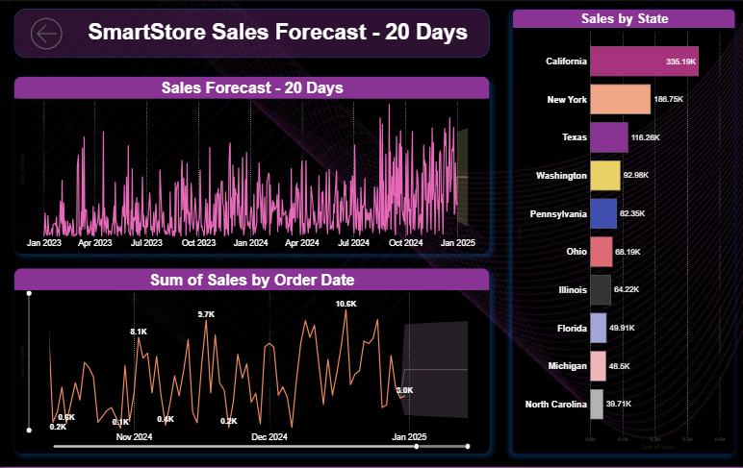

**🤝 Conclusion**

The **Smart Store Sales Dashboard** showcases how **data analysis and visualization** can transform raw data into **actionable business insights**. It demonstrates the value of **business intelligence tools** in driving smarter decisions and improving sales strategies.